Software Engineering 2017

# Group ID: B04

## *Automatic Traffic Challan Management*

|  |
| --- |
| 20171005_230039.jpg |

|  |  |  |
| --- | --- | --- |
| Roll Number | Name | Role (PO+DEV/SM+DEV/DEV) |
| 15ucs121 | Satyam Kumar | DEV |
| 15ucs138 | Shubham Mangal | SM + DEV |
| 15ucs154 | Utsav Singh | PO + DEV |
| 15ucs122 | Satyam Shubham | DEV |
| 15ucs108 | Rishabh Tiwari | DEV |

*+ order the names as per the order in the team selfie (left to right)*

**Section 1**

|  |
| --- |
| **Project overview**  Traffic Challan Management system provides the following functionality:   1. Offers the data about commuters using their vehicle’s license number, 2. Penalize the road rules offenders by issuing the challan against the vehicle’s license number, 3. Helps the traffic officer to manage and regulate the challan generation automatically and hassle free, 4. Provide platform to pay the challan fine amount online |

|  |
| --- |
| **System purpose**  To reduce difficult paperwork of challan generation by traffic officer, to efficiently generate challan and reduce the time consumed in manual work, to provide better traffic regulations, and to provide online platform for offenders to pay fine. |

**Section 2**

**URI for System Demo**

[**Demo Link**](https://automatic-traffic-challan.firebaseapp.com/)

**URI for UI/UX wireframes (shared Lucidchart document folder)**

[**Lucid Folder Link**](https://www.lucidchart.com/invitations/accept/b21cf4ca-f300-4ebf-be6b-9441bb8b975f)

**URI for Scrum project management report (shared Google Drive folder)**

[**Scrum Burndown Chart**](https://docs.google.com/a/lnmiit.ac.in/spreadsheets/d/19CKbj7voB_XqLPR1imq7zm9rq9j1quwTVfvpu1Lnj0c/edit?usp=sharing)

**Section 3**

**Work System Snapshot**

|  |  |  |  |
| --- | --- | --- | --- |
| Customers | | Product/Services | |
| * Traffic Police Authority | | * Challan Generation * Offender Information * Challan Payment * Challan Insights * Traffic Offences Details * Officer Details | |
| Major Activities and Processes | | | |
| * Admin adds details about commuters against their license number * Admin create officers account with appropriate access rights * Traffic officer upload the image of offenders vehicle containing license number * System generate challan from the processed image * System informs the offender about the challan and payment due date * Offender visits the portal and pay the fine for challan * Wireless Control Officer checks status of payment and reminds the offender about the payment due date in case of no payment. * System update the status of due challan to “waiting court order” * Wireless Control Officer Update the status of due challan to “warrant issued” in case of no response from offender * Wireless Control Officer assign a Police Officer to the Challan * Police Officer checks if any offender’s warrant is issued * Police Officer update the status of offender’s arrest * Wireless Control Officer closes the challan after all processing * Commuters can view for any previous challan issued for their vehicle | | | |
| Participants | Information | | Technologies |
| * Offenders * Commuters * Traffic Officer * Police Officer * Wireless Control Officer * Administrator | * License Number * Offender * Challan * Traffic Offences * Payment * Assigned Officer * Warrant | | * Image Processing System * Database System * Payment Providers * Management System |

**Section 4**

**Use case diagram with nested boundary**[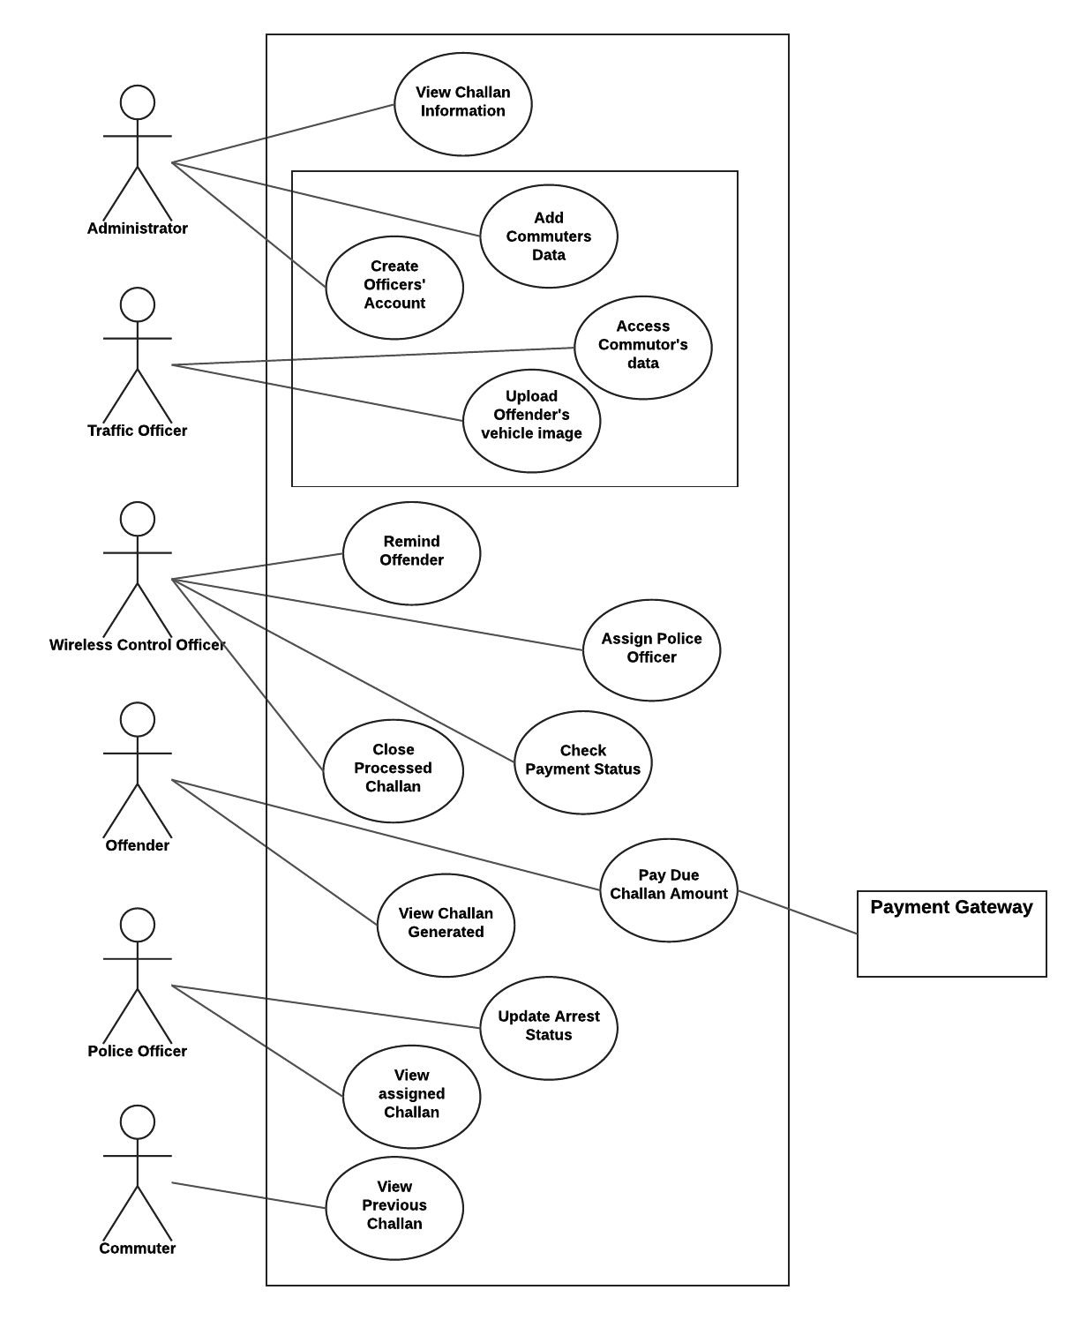](https://www.lucidchart.com/documents/edit/59287be1-79a7-48e9-a94a-4b51be7a2571/0?callback=close&name=docs&callback_type=back&v=2060&s=612)

**Section 5**

**Product Backlog (format sprint 1 rows in bold)**

|  |  |  |  |  |
| --- | --- | --- | --- | --- |
| Story ID | As a/an | I want to … | so that … | Priority (H/M/L) |
| 1 | Administrator | View road offences | Road code of conduct can be ensured | L |
| **2** | **Traffic Officer** | **Upload vehicle image and initiate challan generation** | **Time consumed in paperwork can be reduced** | **H** |
| **3** | **Traffic Officer** | **View offenders**  **information** | **Offender can be informed about challan** | **M** |

|  |  |  |  |  |
| --- | --- | --- | --- | --- |
| Story ID | As a/an | I want to … | so that … | Priority (H/M/L) |
| 4 | Commuter | View challan history | I can see if I have violated any road code. | L |
| 5 | Offender | Access challan | I can pay the challan amount. | H |
| 6 | Wireless Control  Officer | View challans’ details | I can check if challan has been paid or not. | H |

|  |  |  |  |  |
| --- | --- | --- | --- | --- |
| Story ID | As a/an | I want to … | so that … | Priority (H/M/L) |
| 7 | Wireless Control  Officer | Inform Court about the  unpaid challan | Appropriate actions can be  taken against offender by  Court. | M |
| 8 | Wireless Control  Officer | View the warrant  information issued by  court | I can assign the police officer  to the warrant. | M |

|  |  |  |  |  |
| --- | --- | --- | --- | --- |
| Story ID | As a/an | I want to … | so that … | Priority (H/M/L) |
| 9 | Police Officer | View assigned  warrants | I can take appropriate actions  accordingly. | M |
| **10** | **Administrator** | **Create and assign**  **officers’ accounts** | **They can upload and manage**  **challan.** | **H** |

**Sprint 1 Plan (Backlog)**

|  |  |  |  |  |  |
| --- | --- | --- | --- | --- | --- |
| Story ID | As a/an | I want to … | so that … | estimate | actual |
| 2 | Traffic Officer | Upload vehicle image and initiate challan generation | Time consumed in paperwork can be reduced | 2 day |  |
| 3 | Traffic Officer | View offenders  information | Offender can be informed about challan | 2 day |  |
| 10 | Administrator | Create and assign  officers’ accounts | They can upload and manage  challan. | 2 days |  |

**Section 6**

**Acceptance criteria and test result**

(note: a story ID may have multiple rows; one for each acceptance criteria to be tested)

|  |  |  |
| --- | --- | --- |
| Story ID | Acceptance criteria | Test Result |
| 2 | if officer upload wrong image | Right |
| 3 | if offender information is not present | Right |
| 10 | if user try to login with wrong details | Right |
| 2 | if details of image are not useful | Right |
| 3 | if offender data is mis matching | Right |
| 10 | if user forgot his password | Right |

**Section 7**

**Personas**

**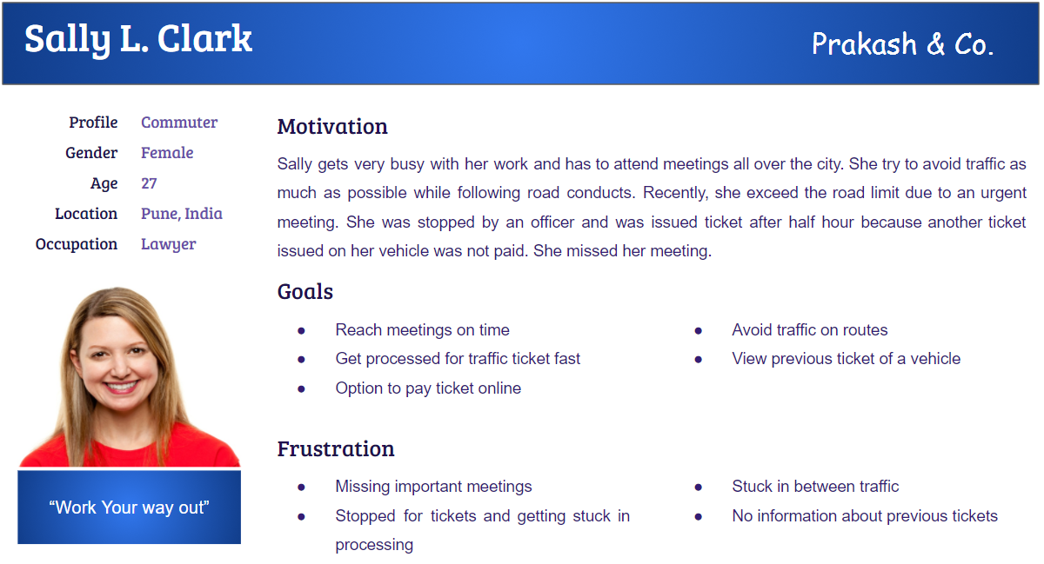**

**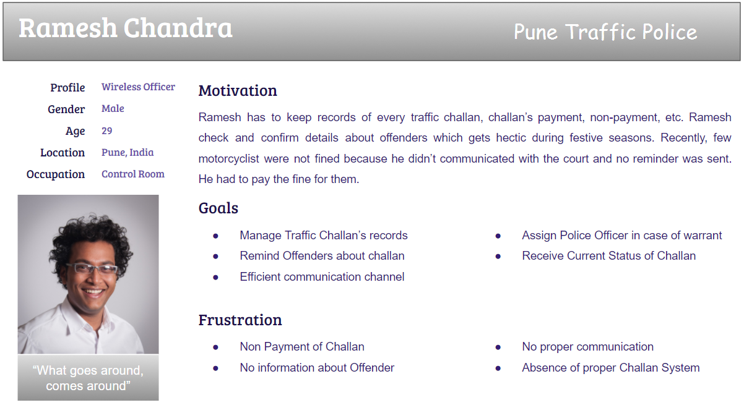**

**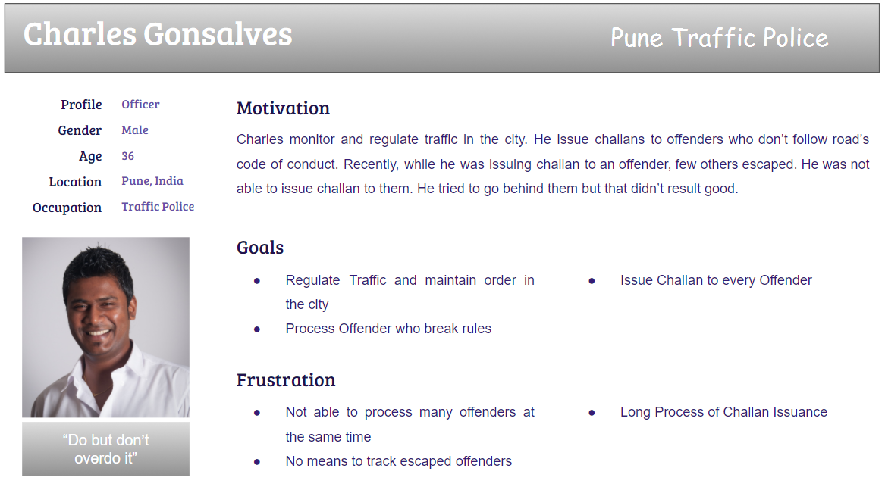**

**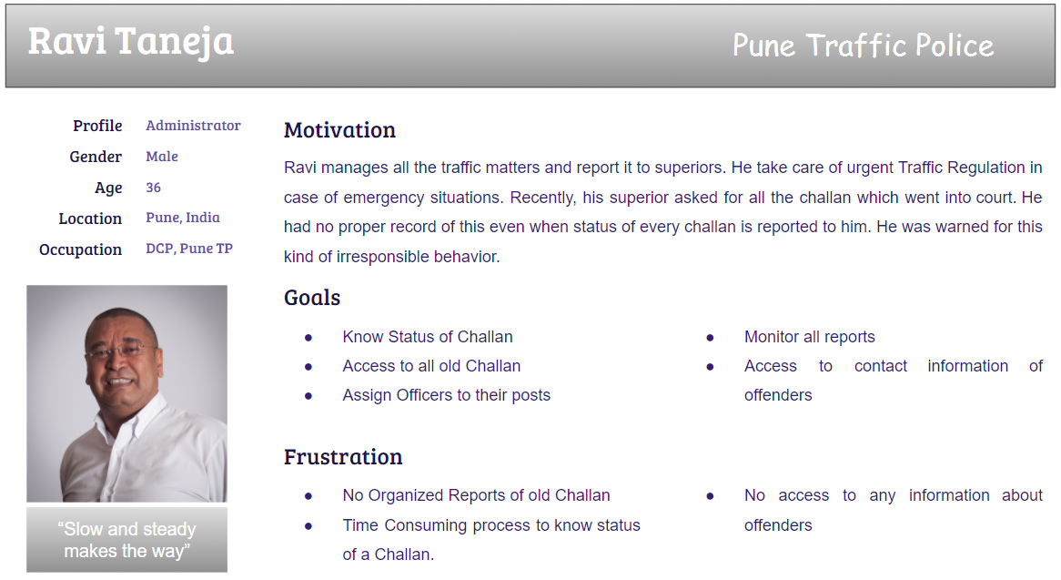**

**Section 8**

**Activity diagram – Top level**

<*linking all the use cases in the use case diagram*>

[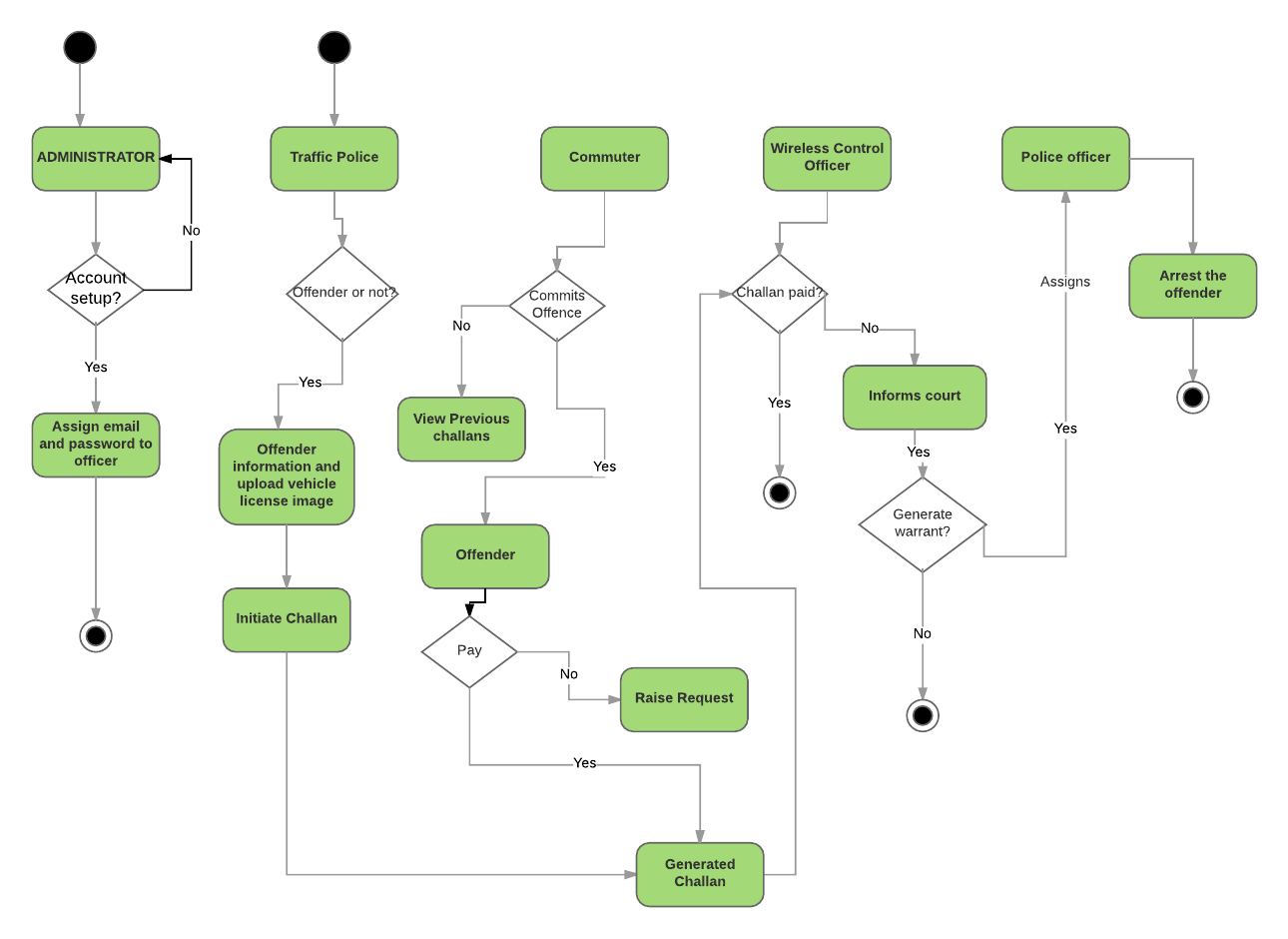](https://www.lucidchart.com/documents/edit/d8edf66f-0d83-4ae6-a130-dfa8875ea149/0?callback=close&name=docs&callback_type=back&v=420&s=645)

**Activity diagrams**

<*Approximately one for each team member with correct notation; diagrams should include business activities/operations – not UI navigation and concepts*>

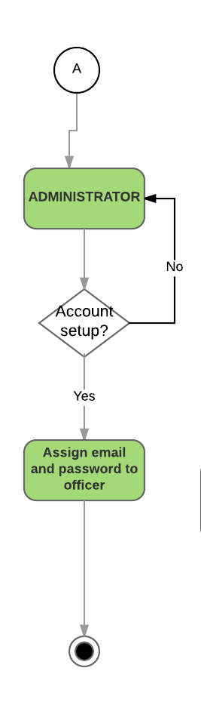

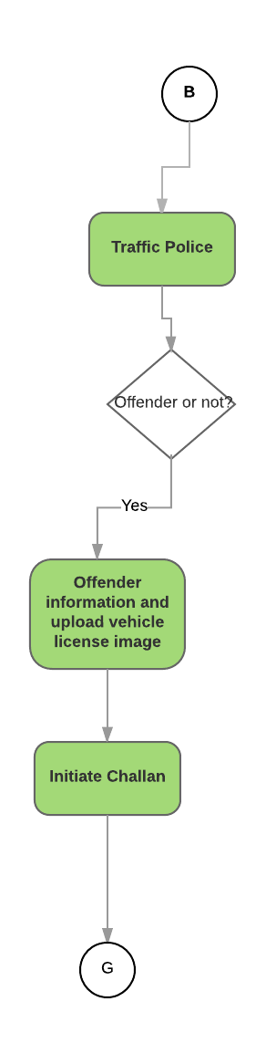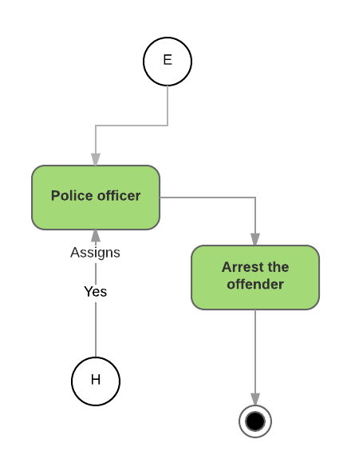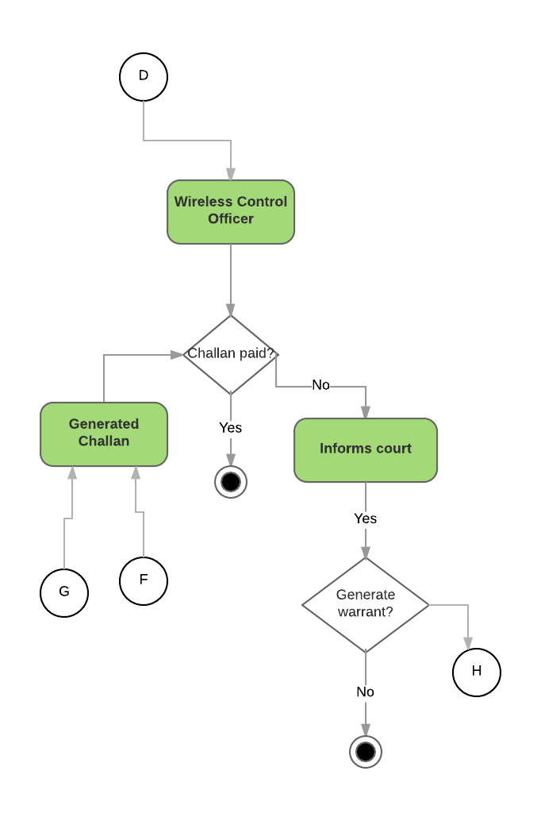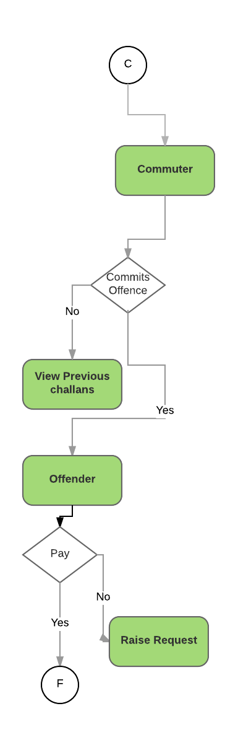

**Section 9**

**Mindmaps for UX/UI for Persona Groups**

**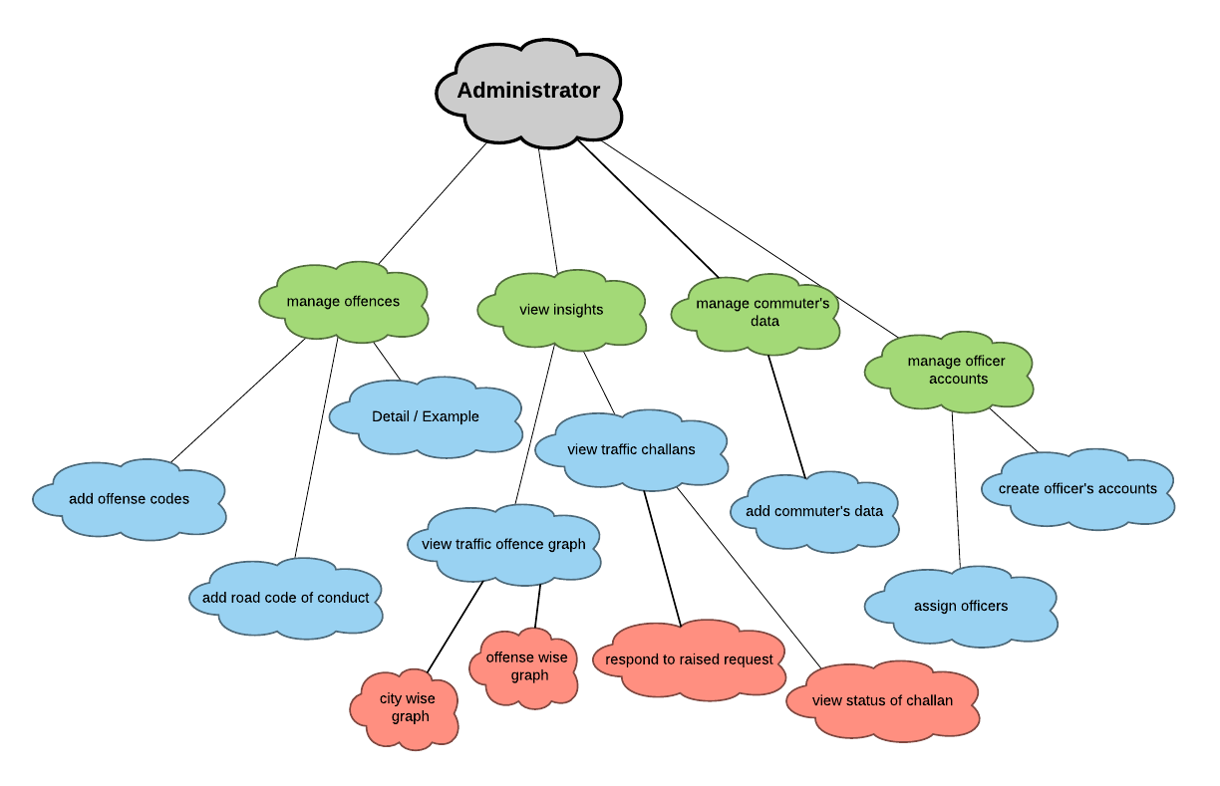**

**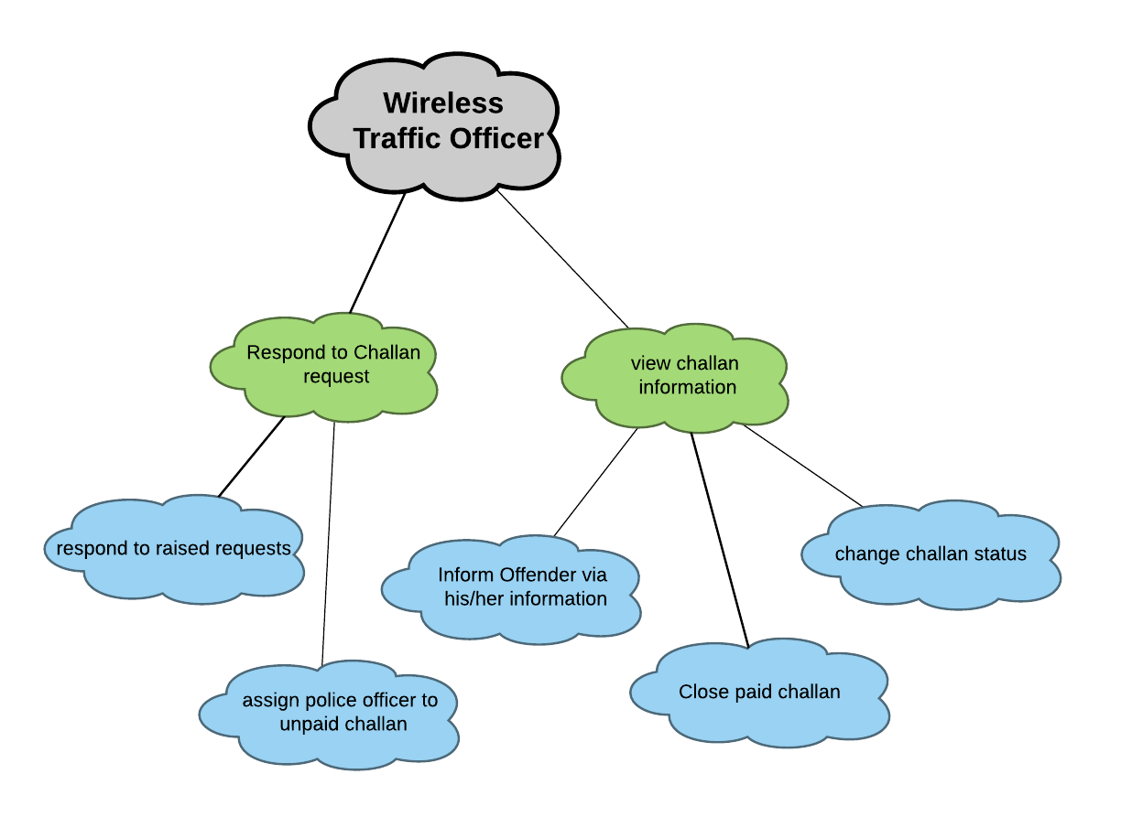**

[**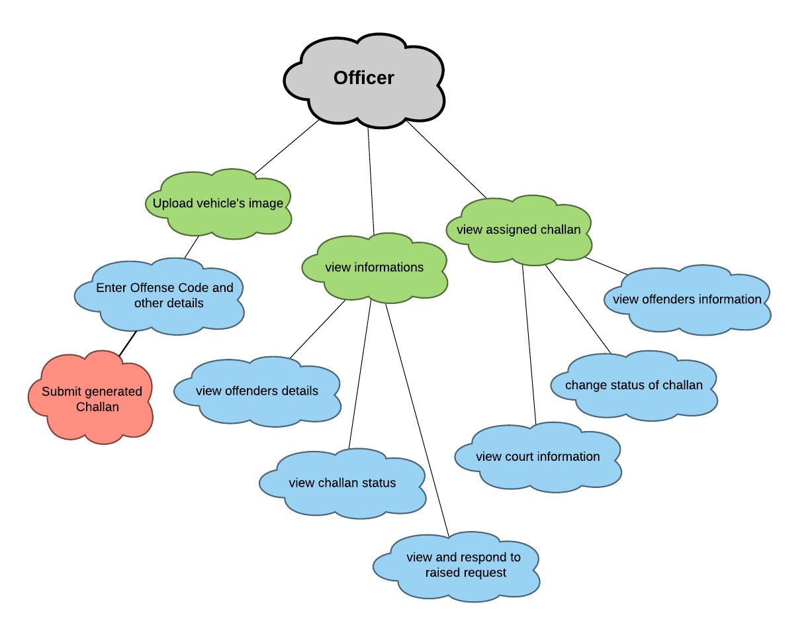**](https://www.lucidchart.com/documents/edit/ce7b4e94-f7a5-4953-b26e-1a3334af5821/0?callback=close&name=docs&callback_type=back&v=1129&s=612)[**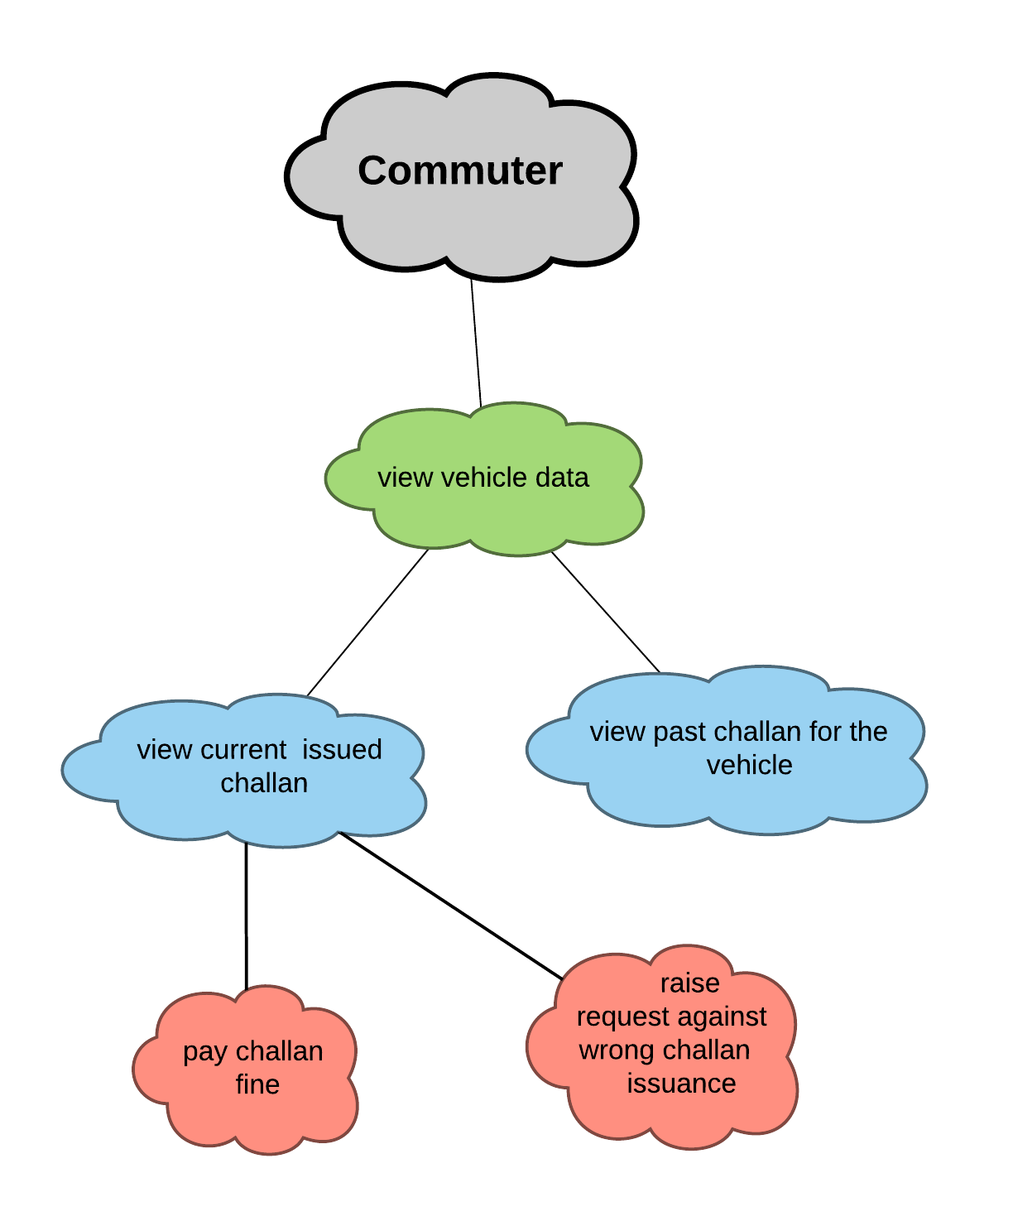**](https://www.lucidchart.com/documents/edit/51aec5b3-a41a-41b3-854e-e1c8e1702908/0?callback=close&name=docs&callback_type=back&v=962&s=612)

**Section 10**

**UI/UX Designs (Wireframes) – For the Sprint 1 functionality**[**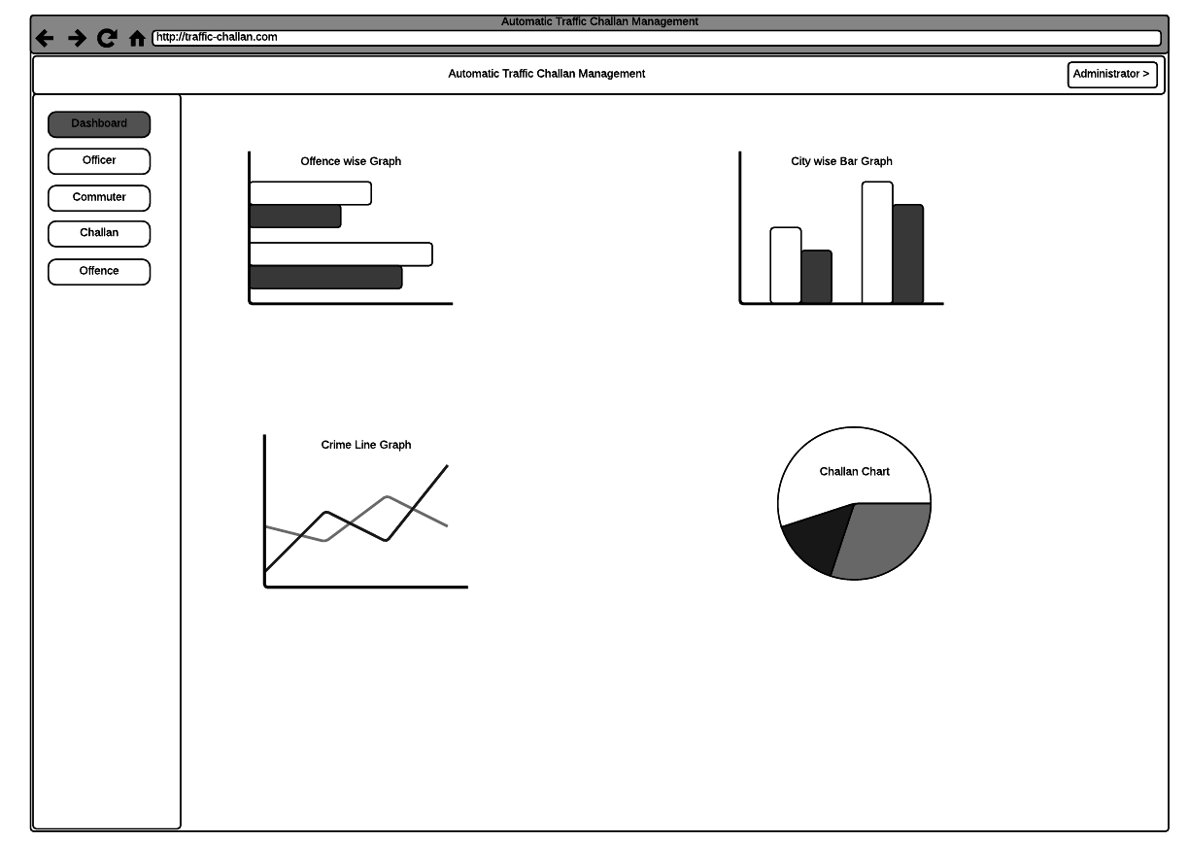**](https://www.lucidchart.com/documents/edit/be77c1e7-0e86-43d3-a302-bc8da413086d/0?callback=close&name=docs&callback_type=back&v=2462&s=612)[**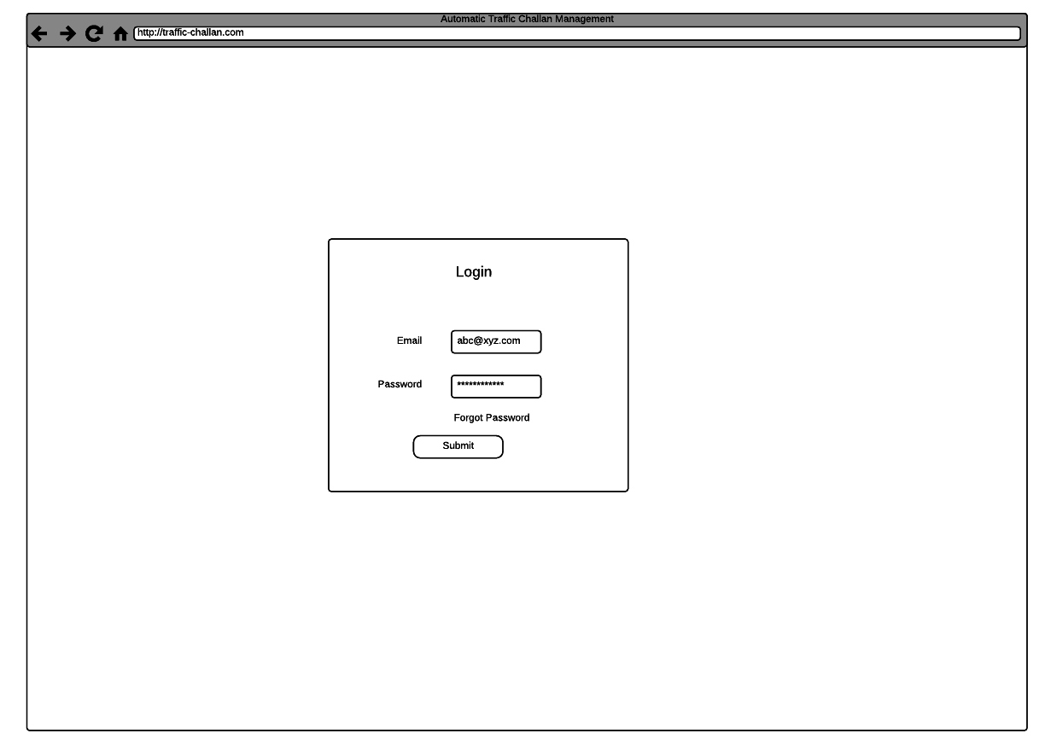**](https://www.lucidchart.com/documents/edit/be77c1e7-0e86-43d3-a302-bc8da413086d/5?callback=close&name=docs&callback_type=back&v=2462&s=612)[**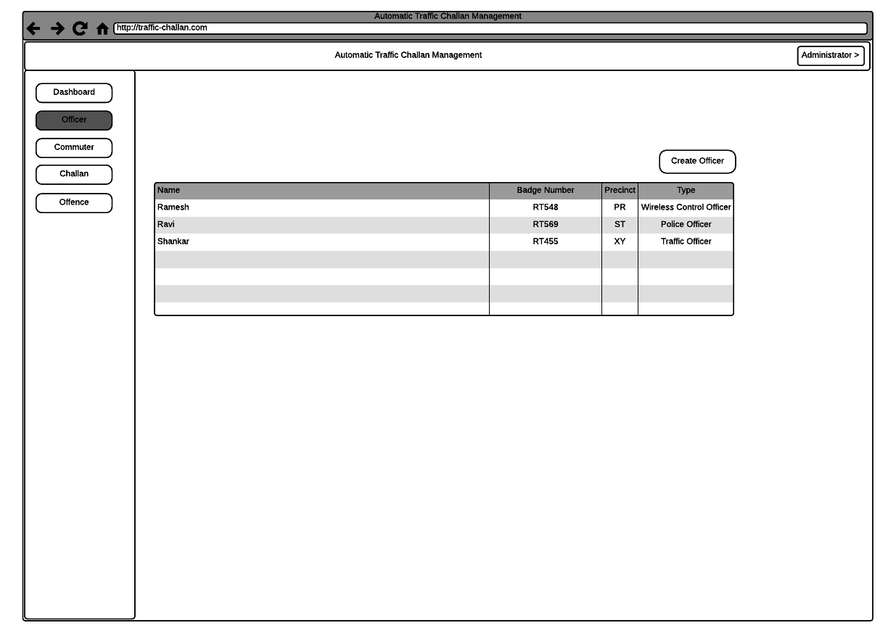**](https://www.lucidchart.com/documents/edit/be77c1e7-0e86-43d3-a302-bc8da413086d/4?callback=close&name=docs&callback_type=back&v=2462&s=612)[**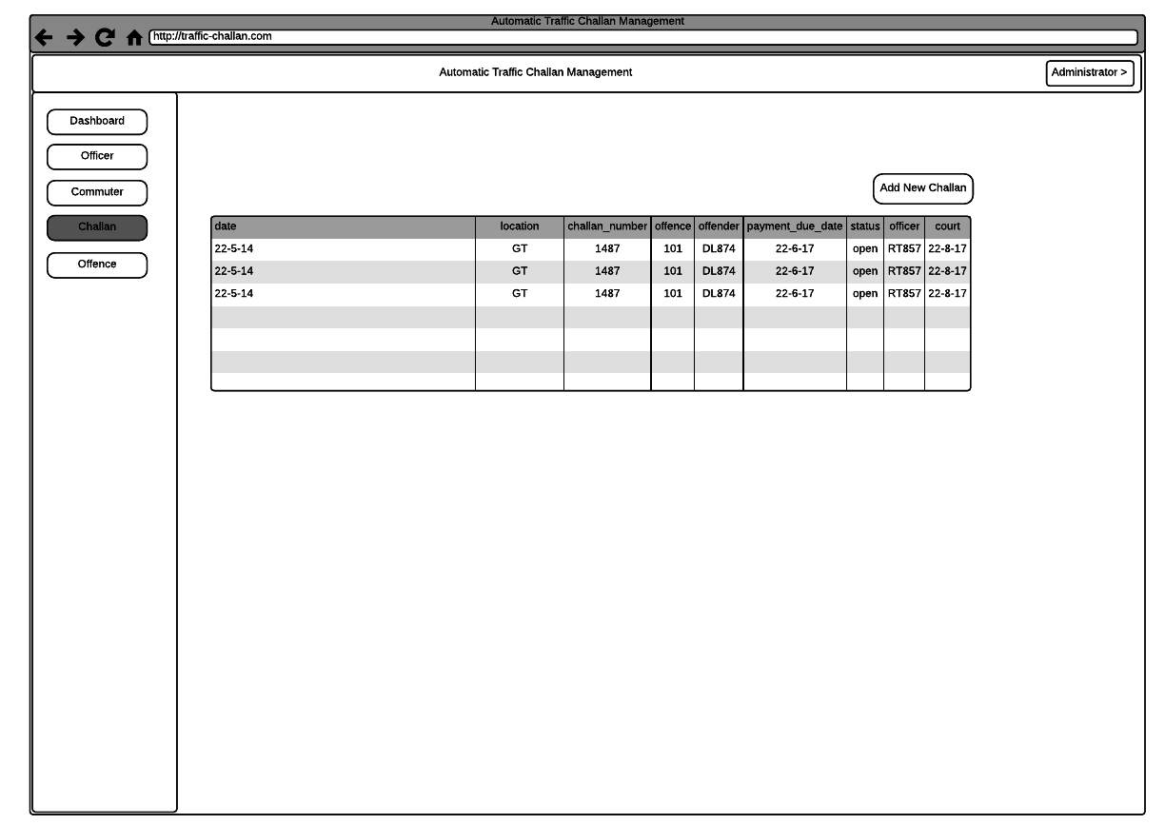**](https://www.lucidchart.com/documents/edit/be77c1e7-0e86-43d3-a302-bc8da413086d/3?callback=close&name=docs&callback_type=back&v=2462&s=612)[**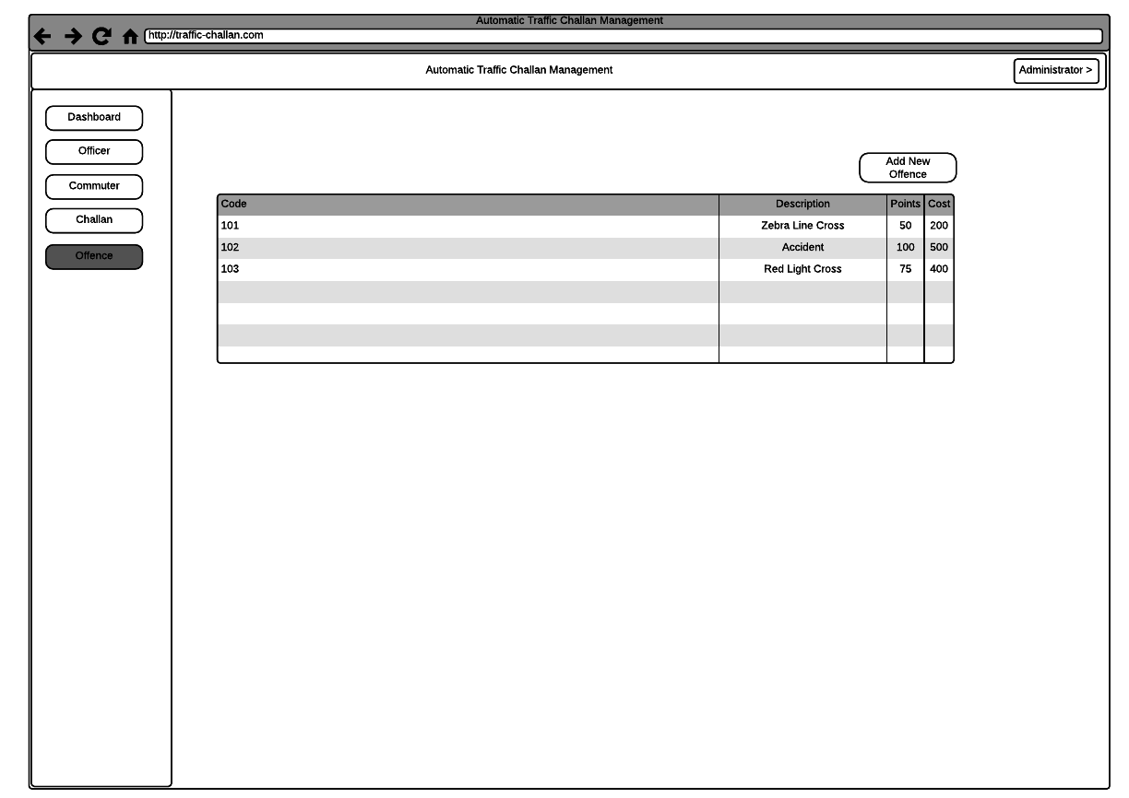**](https://www.lucidchart.com/documents/edit/be77c1e7-0e86-43d3-a302-bc8da413086d/2?callback=close&name=docs&callback_type=back&v=2462&s=612)[**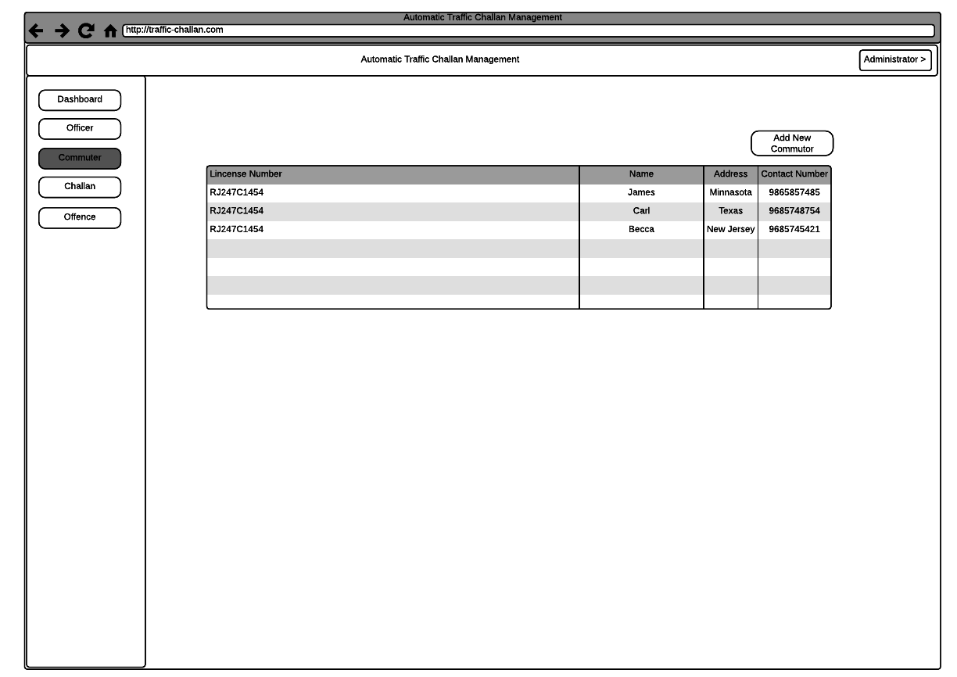**](https://www.lucidchart.com/documents/edit/be77c1e7-0e86-43d3-a302-bc8da413086d/1?callback=close&name=docs&callback_type=back&v=2462&s=612)

**Section 11**

**Class diagram**

<attributes and operations should be listed on the following pages as a table>

[**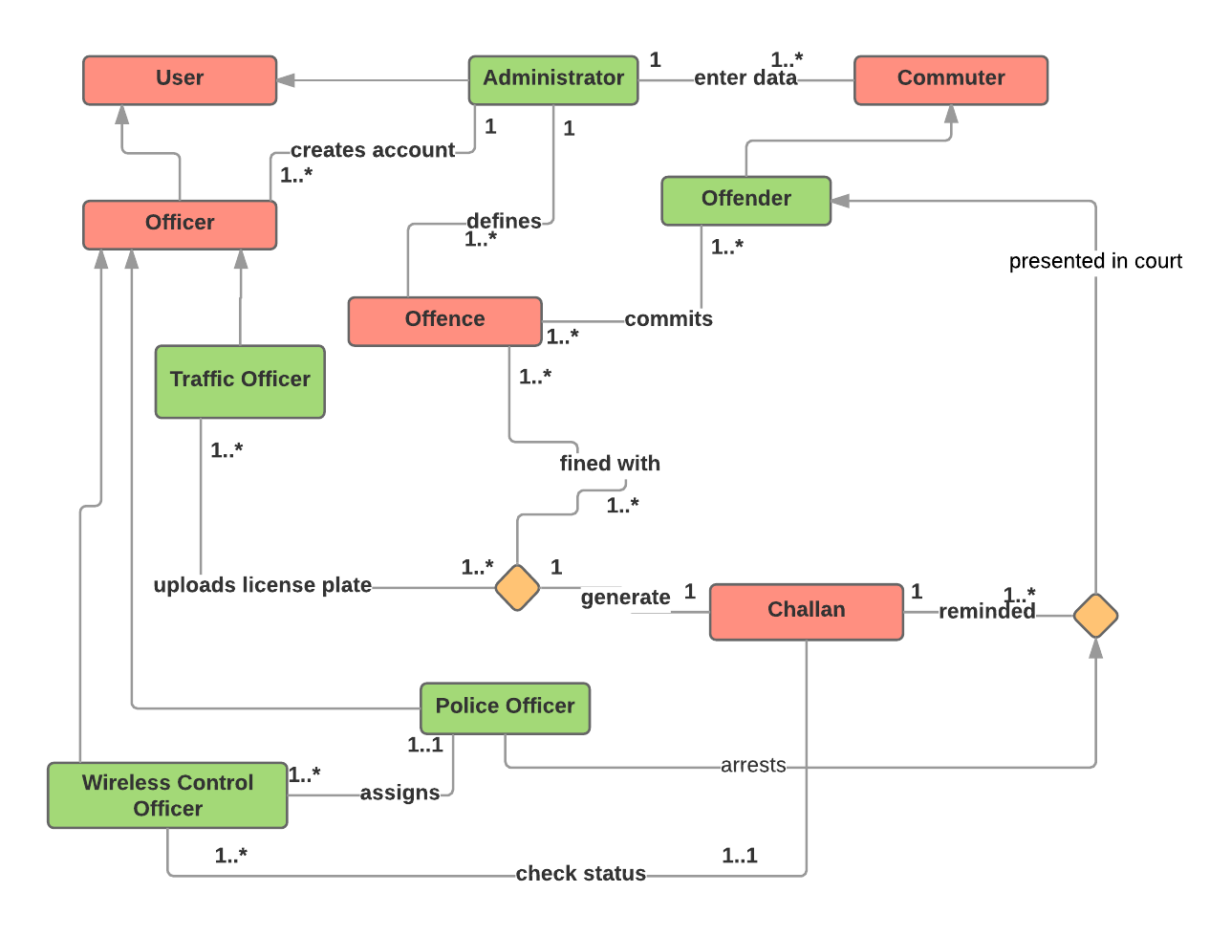**](https://www.lucidchart.com/documents/edit/4105198d-28de-407d-8cdb-9e5385427a56/0?callback=close&name=docs&callback_type=back&v=2551&s=644)

**Attributes and operations**

(show class attributes and operations with underline)

|  |  |  |
| --- | --- | --- |
| Class name | Attributes | Operations |
| Offence | code  description  points  cost | getOffenceCost(code)  getOffences()  createOffence(Offence) |
| Commuter | name  dl\_no  dob  address  contact\_number  dl\_expiry  vehicle\_plate\_number | getCommuter(dl\_no)  getCommuter(vehicle\_plate\_number)  getCommuters()  addCommuter(Commuter)  getAge()  getRemainingDays() |
| Officer | name  precinct  badge\_number  type | getOfficer(badge\_number)  getOfficers()  getOfficers(type)  createOfficer(Officer) |
| Challan | date  location  challan\_number  offence: OFFENCE  offender: OFFENDER  payment\_due\_date  status  officer: OFFICER  court\_date  is\_warrant\_issued  arrest\_status | getChallan(challan\_number)  getChallans()  getStatus(challan\_number)  getFine()  getWarrantStatus(challan\_number)  getArrestStatus(challan\_number)  getDueDays() |
| User | email  password  last\_login | login(email, password)  logout() |

**Scrum Minutes of the Meeting (Two entries per week for each team member)**

**Sprint 1 – Week 1**

|  |  |  |  |
| --- | --- | --- | --- |
| Team member | Work completed | Work planned | Impediments |
| Rishab Tiwari | Partially completed | Build schema for database | difficult to think schema |
| Satyam Kumar | completed | identify classes and its attribute | classes were hard to differentiate |
| Satyam Shubham | completed | build UI/UX for login | no difficulty |
| Shubham Mangal | completed | implement login component, setup angular project structure | difficulty in anonymous login |
| Utsav Singh | completed | deploy on bluemix | No deployment due to docker incompatibility |

**Week 3**

|  |  |  |  |
| --- | --- | --- | --- |
| Team member | Work completed | Work planned | Impediments |
| Rishab Tiwari | completed | build schema for database | Json is difficult to edit |
| Satyam Kumar | completed | identify methods for classes | no difficulty |
| Satyam Shubham | partially completed | build UI/UX for table | no difficulty |
| Shubham Mangal | completed | host on firebase | no difficulty |
| Utsav Singh | completed | tested the site workflow | no difficulty |

**Week 3**

|  |  |  |  |
| --- | --- | --- | --- |
| Team member | Work completed | Work planned | Impediments |
| Rishab Tiwari | partially completed | integrate NoSql database | CRUD functions are hard to implement |
| Satyam Kumar | completed | implement sprint 1 functions | some functions were hard to implement |
| Satyam Shubham | completed | build UI/UX for navbar and sidebar | no difficulty |
| Shubham Mangal | partially completed | work on license plate recognition | recognition library sometimes give improper results |
| Utsav Singh | partially completed | tested the implementation of others | testing and debugging hard |

**Sprint 1 Summary**

**Review Summary (about the product)**

|  |  |
| --- | --- |
| 1 | UI/UX are working efficiently,  User can login into his/her account,  Database queries are working,  Administrator is able to see all data |
| 2 | Creation of commuter data, offence data is fast,  Officer’s account can be created,  Vehicle’s image can be uploaded,  Data about image is being fetched |
| 3 | due to docker incompatibilities, website is hosted on firebase temporarily. |

**Retrospective Summary (about the process)**

|  |  |
| --- | --- |
| 1 | Using NoSql is proving to be very feasible as database’s schema is changing frequently,  scheming the database is tedious task |
| 2 | Authentication is done via firebase API which is taking care of login and log out of users, |
| 3 | Data fetched from the Recognition API is very useful and can be used further in the website, implementation is very easy. |